**Assignment 3**

The task for this assignment involves the creation of a room set in the evening with dim lighting, object interaction, and environmental sounds.

**The Room**

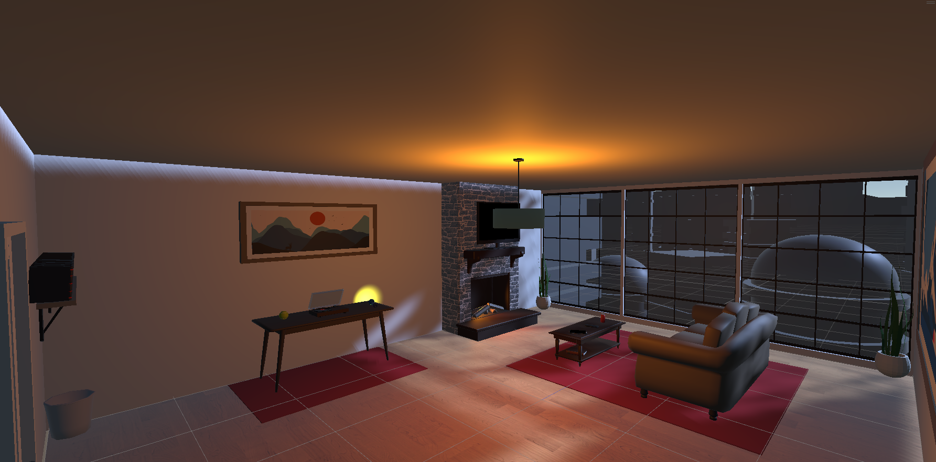

Figure - Overall look of the room

As seen in Figure 1, the room has been designed to have a cozy and spacious atmosphere. A couch, coffee table, fireplace, and a TV have been placed to make it feel homely. The evening with dim lighting achieves in creating a relaxing atmosphere.

**The Evening Sky**

To achieve the feeling of evening time, I changed the environmental lighting conditions. I toned down the intensity multiplier option under the “Environmental Lighting” section (as seen in Figure 2) to 0.41 to make the ambient lighting of the scene to be darker, but not pitch black so that it can still feel like the moon is out.

Figure - The environmental settings used to achieve the night sky.

To further enhance this feeling, I placed a directional light object inside the room to simulate the light cast by the moon going through the windows. I set the temperature slider to its maximum to (counter-intuitively) create the feeling of coldness from its blue-ish color it creates. These settings can be seen in Figure 3.

Figure - The directional light settings to simulate moonlight through the windows.

**Dim Lighting**

Figure - The room with dim lighting

To create the sense of comfort and coziness in a dark and cold room, dim lighting is needed. To achieve this, I made use of a ceiling lamp that emits an orange-like color hue. As seen in Figure 4, the light generated by the lamp was not designed to totally brighten the room, but instead enough to light the center of the room while also establishing the appropriate atmosphere. Notice the center of the room looks relatively warm but the corners are the room are colder. This effect was created using a point light placed inside the lamp. Its settings can be seen in Figure 5. I played around with the intensity a bit and changed the color hue to orange.

Figure - Point light settings for dim lighting

**The Fireplace**

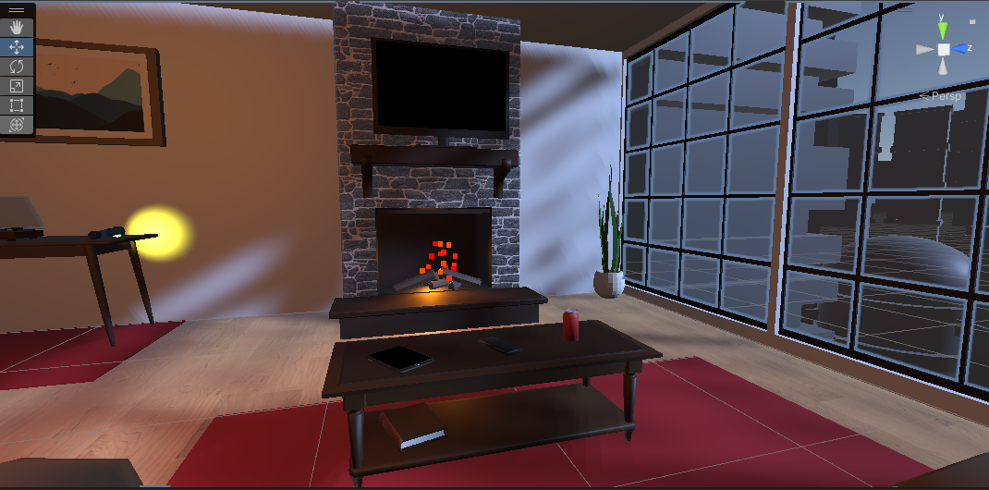

Figure - The fireplace set up in the room.

To even increase the level of coziness, a fireplace was added into the room (see Figure 6). This fireplace emits fire particles, warm lighting, and 3D audio. The warm lighting was achieved using a spotlight that emits the same color hue as the ceiling lamp, while the 3D audio plays continuous fire cackling sound with a 3D spatial blend.

**The Record Player**

Figure - The record player

On a table to the left of the fireplace there is a record player. This record player plays classical music on loop. To simulate that the record player is actually playing the song, the vinyl disk is rotates continuously and the handle is placed on top of the disk. The code to spin the disk is very simple and can be seen in Figure 8.A computer screen shot of a program

Figure - Code to spin the disk

**Interactions**

There are several interactions that can be informed within this room. This includes ways to navigate the scene as well as objects that can be interacted with.

**How to Interact**

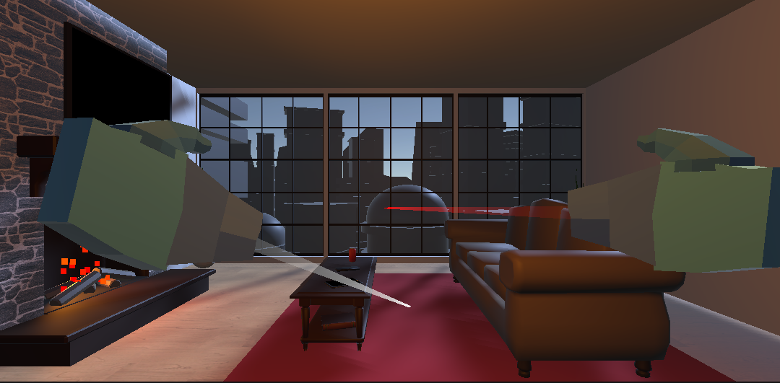

Figure - User interaction using raycasts

There are two ways to perform interactions: raycasts and grip.

Raycasts are used to point into objects to teleport. This is the main method by which to move around the room. By holding the shift or spacebar (for emulated joystick controls) and then pressing the B button, a ray will be cast from the virtual hands as shown in Figure 9. This ray becomes more opaque the further it is from the virtual hands. If it detect any objects that can be interacted with, the ray will turn white. Otherwise, it will be red. Press G to interact with the object.

The other method for interaction is using grip. This is performed simply by moving the virtual hands close to an object until it collides with it, and then pressing G to pick the item up.

**Teleporting**

The main method in traversing this scene is by using teleportation. The user can teleport around the room by interacting with any of the rugs laid out in the room through raycasts (as seen in Figure 7). Additionally, there is also a potted plant the user can point their raycasts towards in order to teleport near the plant so they can interact with the watering can a lot easier (see Figure 9).

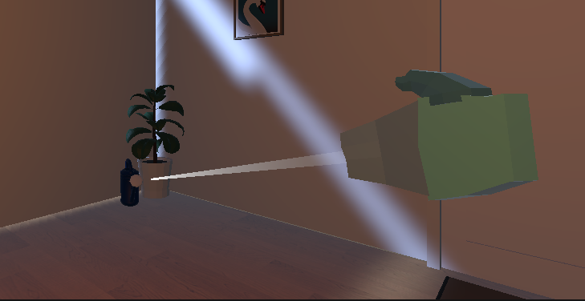

Figure - The user can point a raycast to one of the potted plants to teleport

**Interactable Objects**

There are a bunch of things within the room that can be interacted with by the player by grabbing the object with their virtual hands. Some of these items perform different things when interacting with it.

TV

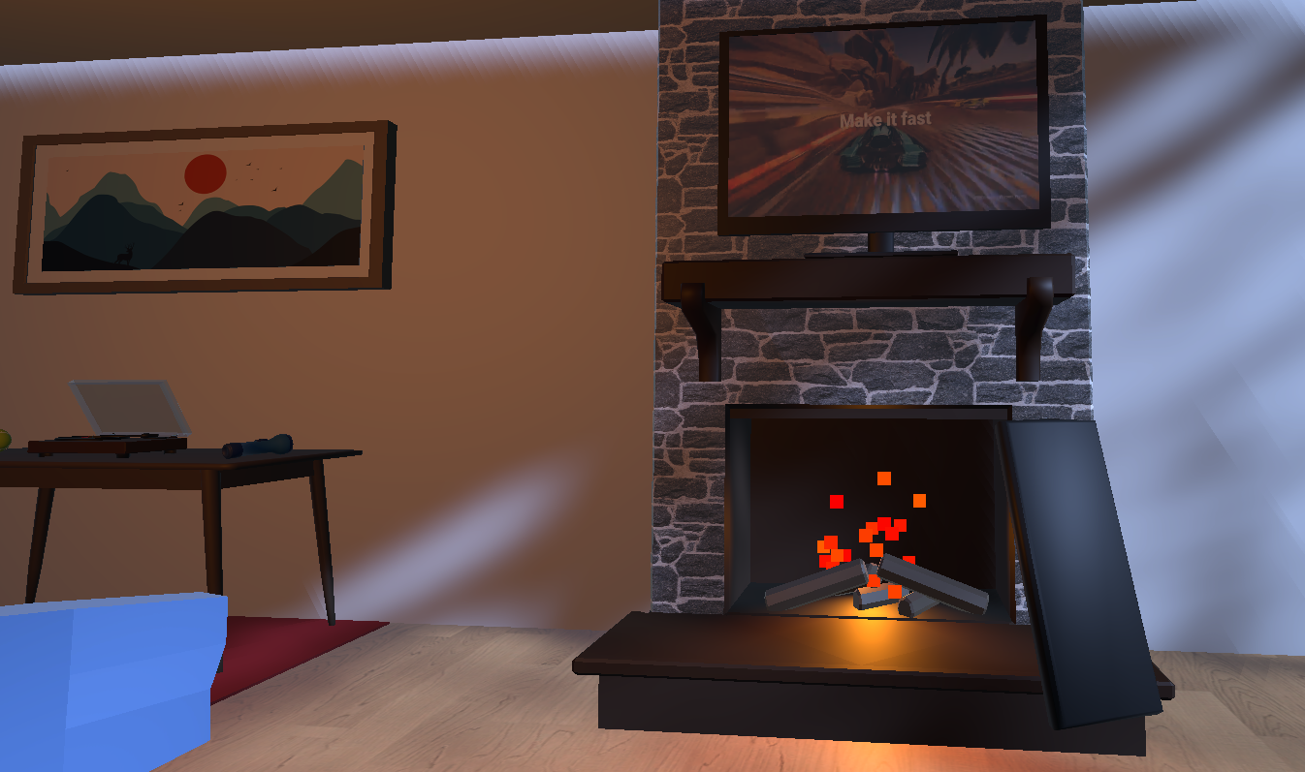

Figure - Interactive TV and remote

On top of the fireplace there is a TV that can play a video. To interact with it, the player will need to interact with the TV remote that is placed on top of the coffee table. When grabbing the TV remote, the user can press the left mouse button to play/pause the video on the TV. The remote will also have a light indicator when the player presses it.

Tablet

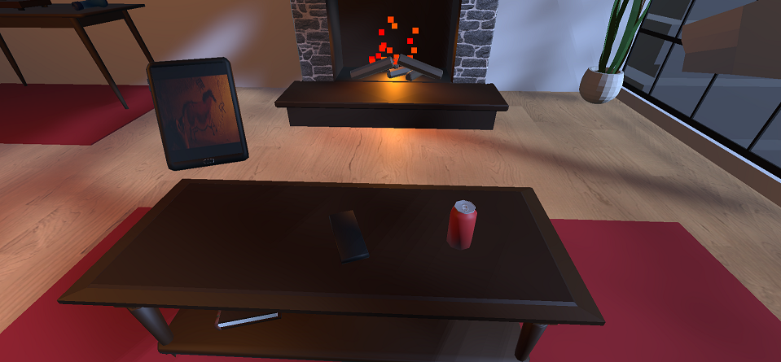

Figure - Interactive tablet

There is also a tablet on the coffee table that the user can pick up and play a video by pressing the left mouse button. It works almost the same as with the TV, but the user can interact directly with the table instead of needing a separate remote.

Bouncing Ball

Figure - The interactive tennis ball

On the table where the record player is located, there is a tennis ball to the left of the recorder that the player can interact with. By picking up the ball, players will be able to see it bounce on the floor several times when they release their grip. A bouncing audio will also play every time the ball bounces.

Flashlight

Figure - Flashlight shining the potted plant

To the right of the record player there is a flashlight that the player can interact with. By picking up the flashlight, the player can turn it ON/OFF by pressing their left mouse button. The light that the flashlight emits is not particularly bright, but it is enough to light a certain area of the room.

Watering Can

Figure - Using the watering can to water the potted plant

In one of the corners of the room lies a potted plant and a watering can beside it. The user will be able to interact with the watering can by grabbing it with their virtual hand. When the watering can is tilted on a certain angle, water particles may start to drop. This is to simulate as if the user can actually water the potted plant. A looping sound effect of watering being poured will be played as well to add to the immersion.